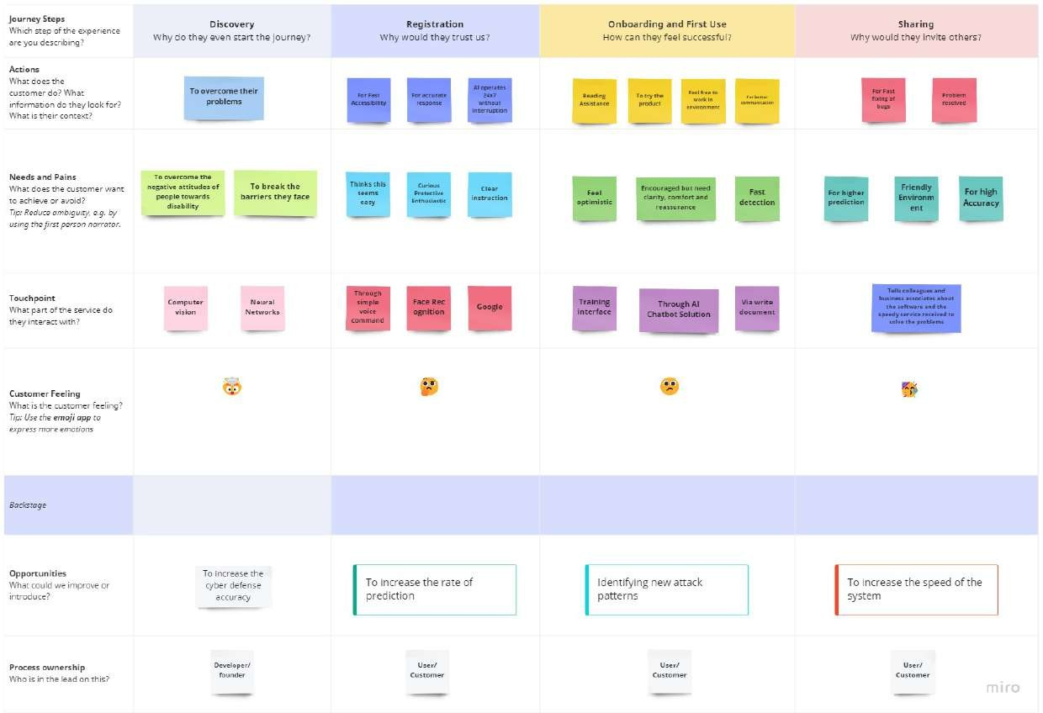 **CUSTOMER** **JOURNEY**

**TEAM ID:** PNT2022TMID21004